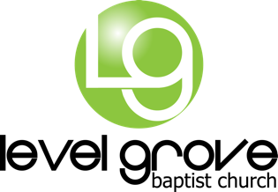

At Level Grove Baptist Church, we are very aware of the precautions and measures we should take to be a clean, healthy, and safe place in light of the COVID-19. We love you all and we are all in this together as we show the world the difference between wisdom and fear. No member of Level Grove Baptist Church has been diagnosed with COVID-19 and our prayers are with those in other areas who have. Our plan is to gather every Sunday morning, unless there are extraordinary circumstances. All children activities on Sunday morning have been postponed until further notice. Our Wednesday night activities are postponed until further notice. Here are a couple of simple notes about COVID-19 in regard to what we are doing and what we are asking of each of you:

What Can I Do?
- Stay home if you are sick. Watch Level Grove Baptist Church on YouTube Live. You can access the link on our Facebook page.
- If you have been exposed to anyone with the Coronavirus, the flu, or any other contagious condition, please stay home for 14 days (per the CDC).
- If you have traveled to China, Iran, Italy, or South Korea or have recently been aboard a cruise ship, please stay home to watch your symptoms for 14 days (per the CDC).

What Are We Doing?
- We are sanitizing highly-touched surfaces before and after every service such as doors, water fountains, check-in stations, and sinks. This includes a heavy focus on children’s ministry areas.
- Our staff and volunteer teams will wash their hands frequently and will stay home if they are sick.
- We have numerous hand sanitizer stations throughout our campus for everyone to use.

What is Our Spiritual Responsibility?
- We need to remember that followers of Jesus do not need to live in fear. He has power over all things, and we are eternally secure.
- Our calling is to love our neighbor, whether they are sick or healthy.
- Pray for God’s mercy and wisdom for US and global leaders as they deal with this issue.

